KJSCE/IT/SYBTech/SEM IV/AA/2020-21
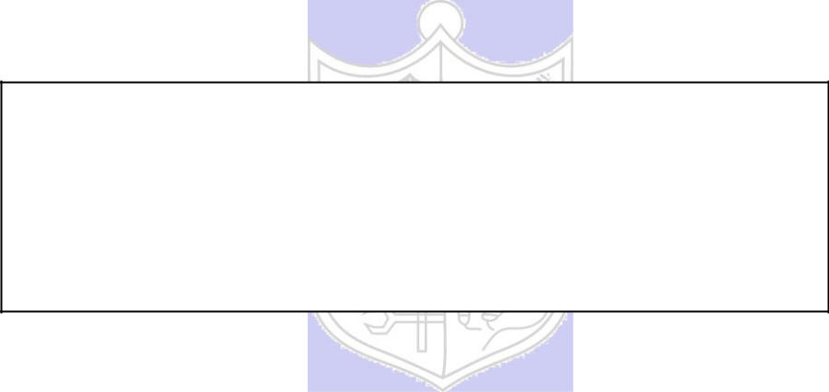

Experiment No. : 8

Title: 15 puzzle problem using Branch and bound

(Autonomous College Affiliated to University of Mumbai)
KJSCE/IT/SYBTech/SEM IV/AA/2020-21

Batch:B2

Roll No.:1914078

Experiment No.:8

Aim: Implement 8/15 puzzle problem using Branch and bound.

Algorithm:

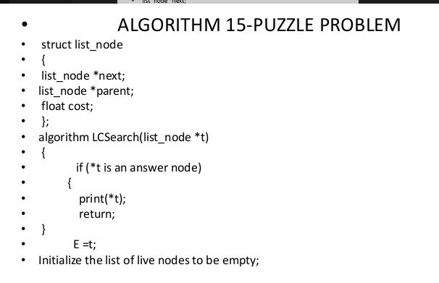
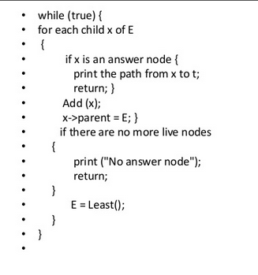
Example of 8/15 puzzle problem using Branch and bound Step by Step Execution

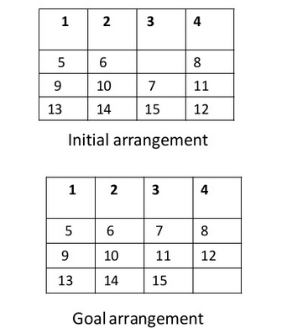
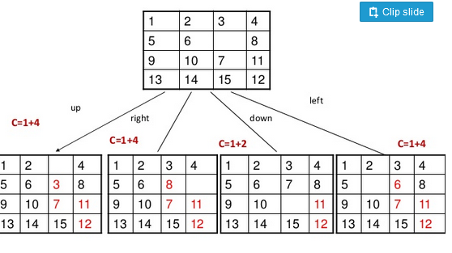
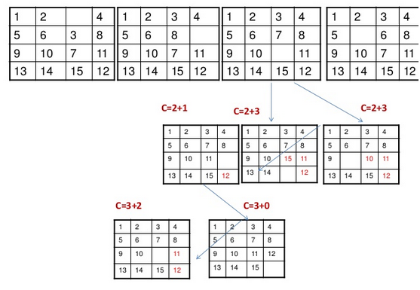

(Autonomous College Affiliated to University of Mumbai)

KJSCE/IT/SYBTech/SEM IV/AA/2020-21

Derivation of Analysis:

Time complexity.

2^^{n}

Program(s):
#include<bits/stdc++.h>

#define rep(i,n) for(int (i)=0;(i)<(int)(n);++(i))
#define reu(i,l,u) for(int (i)=(int)(l);(i)<(int)(u);++(i))
#define each(it,o) for(auto it= (o).begin(); it != (o).end(); ++ it)
#define ios freopen("i","r",stdin); freopen("o","w",stdout);
#define INF 99999

using namespace std;

int direction[4][2] = {{1, 0},
{0, -1},
{-1, 0},
{0, 1}};

class sub_tree{
public:
sub_tree* parent;
vector<vector<int>> cur_mat;
int x,y, moves, cost;
int new_x, new_y;
sub_tree(vector<vector<int> > input_mat, vector<vector<int> > goal,int x, int y, int new_x, int new_y,int input_moves, sub_tree* parent_node)
:x(x), y(y), new_x(new_x), new_y(new_y), parent(parent_node), cur_mat(input_mat){
moves = input_moves +1;
}

void print_mat(){
rep(i,4){
rep(j,4){
cout<<cur_mat[i][j]<<" ";
}
cout<<endl;
}
}

};

struct comp{
bool operator()(const sub_tree* lst,const sub_tree* rst){
return lst->cost+lst->moves > rst->cost+rst->moves;
}
};

int calculateCost(vector<vector<int> > goal, vector<vector<int> > cur_mat){
int cost = 0;
rep(i, 4){
rep(j, 4){
if(cur_mat[i][j] != goal[i][j]){
cost++;
}
}
}
return cost;
}

void print_steps(sub_tree* last_step){
if(last_step == NULL){
return;
}
print_steps(last_step->parent);
last_step->print_mat();
}

int isWithinBounds(sub_tree* min,int x, int y){
if(x >= 0 && x < 4 && y >= 0 && y < 4){
return 1;
}
return 0;
}

void solve(vector<vector<int> > start, vector<vector<int> > goal, int x, int y){
priority_queue<sub_tree*, vector<sub_tree*> ,comp> pq;
sub_tree* root = new sub_tree(start, goal, x, y, x, y, 0, NULL);
root->cost = calculateCost(goal, root->cur_mat);
pq.push(root);
while(!pq.empty()){
sub_tree* min = pq.top();
pq.pop();
if(min->cost == 0){
print_steps(min);
return;
}
rep(i, 4){
if (isWithinBounds(min, min->new_x + direction[i][0], min->new_y + direction[i][1])){
sub_tree* child = new sub_tree(min->cur_mat, goal,min->new_x, min->new_y, min->new_x + direction[i][0], min->new_y+direction[i][1], min->moves +1, min);
swap(child->cur_mat[child->x][child->y], child->cur_mat[child->new_x][child->new_y]);
child->cost = calculateCost(goal, child->cur_mat);
pq.push(child);
}
}
}

}

int main(){
ios
vector<vector<int>> start;
start.resize(4);
for (int i = 0; i < 4; ++i)
start[i].resize(4);
int a=0;
rep(i, 4){
rep(j, 4){
cin>>start[i][j];
if(start[i][j] == 0){
a++;
}
}
}
if(a>1){
cout<<"Invalid\n";
return 0;
}
vector<vector<int>> goal = {
{1,2,3,4},
{5,6,7,8},
{9,10,11,12},
{13,14,15, 0}
};
cout<<"Hello\n";
solve(start, goal, 1, 2);

}

Output(o):

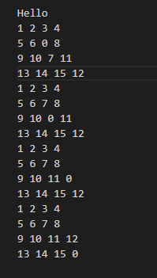

(Autonomous College Affiliated to University of Mumbai)
KJSCE/IT/SYBTech/SEM IV/AA/2020-21

Questions:- Explain how to solve the Knapsack problem using branch and bound.
Ans)
- Draw a table say ‘T’ with (n+1) number of rows and (w+1) number of columns.
- Fill all the boxes of 0th row and 0th column with zeroes as shown-

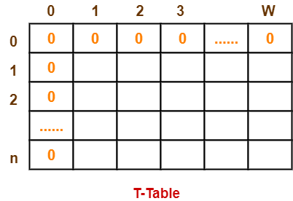

Step-02:

Start filling the table row wise top to bottom from left to right.
Use the following formula-
T (i , j) = max { T ( i-1 , j ) , value_{i} + T( i-1 , j – weight_{i} ) }

Here, T(i , j) = maximum value of the selected items if we can take items 1 to i and have weight restrictions of j.

- This step leads to completely filling the table.
- Then, value of the last box represents the maximum possible value that can be put into the knapsack.

Step-03:

To identify the items that must be put into the knapsack to obtain that maximum profit,
- Consider the last column of the table.
- Start scanning the entries from bottom to top.
- On encountering an entry whose value is not same as the value stored in the entry immediately above it, mark the row label of that entry.
- After all the entries are scanned, the marked labels represent the items that must be put into the knapsack.

Outcome:

Understand Backtracking and Branch-and-bound algorithms

Conclusion: (Based on the observations):
Learned about 15 puzzle problem and solved it using branch and bound approach

References:

- Richard E. Neapolitan, " Foundation of Algorithms ", 5th Edition 2016, Jones & Bartlett Students Edition

- Harsh Bhasin , " Algorithms : Design & Analysis", 1st Edition 2013, Oxford Higher education, India

- T.H. Coreman ,C.E. Leiserson,R.L. Rivest, and C. Stein, " Introduction to algorithms", 3rd Edition 2009, Prentice Hall India Publication

(Autonomous College Affiliated to University of Mumbai)

